Agenda PINTAD
Feb 24th, 2017, 11am EST

- Welcome

- Follow-up on the founding of an imaging-specific CDISC User Group initially under the PINTAD umbrella (for expressions of interest please contact daniel.clark@PAREXEL.com)

  - Only one response so far- is there no interest?
  - Dan Clark to create a brief statement to share with PINTAD to garner further support. It was suggested to target specifically data managers and programming team members- however this should be an important topic for all of us.

- Further update on user stories/ Software Standards for Extending the PACS Environment/ DICOM Part 19
  - Developing “User Stories” around the topical areas of Companion Diagnostics and Clinical Trials for likely discussion within WG-23. Misha will continue to solicit inputs from those within PINTAD that showed an interest following the Oct 28th presentation.
  - Larry Tarbox mentioned that DICOM WG-23 (Application Hosting) has reconvened, and will be considering proposals for improving the existing application hosting, and for a new generation of APIs based on RESTful web services. They are accepting user stories as we speak.
  - He encouraged PINTAD members to join the observer list or become active members if interested. He will create a brief statement to share with the group that includes info on how to join.

- Update on Value Proposition of Imaging PINTAD subgroup
- Brian Garra FDA/ VA, Kim Leigh/ Amgen and Peter Steiger/PAREXEL, Susanta Sarkar/ Cadenzamed leading the effort
- Brian Garra and Susanta Sarkar mentioned that the group has been collecting information and details on the value of imaging in clinical trials and are now shaping the content of a potential PINTAD statement.
- Susanta Sarkar to circle back to the group and let us know when they are ready for an update

- Update on the final push for a consensus on Incidental Findings Reporting

  - 12 in support of both portions
  - 1 in support of Part I but not Part II
  - 2 voted against both parts

  - Can we work towards more responses?

  - Brian Garra suggested to circulate a red-lined document to give people a better sense of what has been changed from the prior version

  - Annette Schmid to reach out to individuals and the group to encourage more voting. We need to have at least 1/3 of the members on the distribution list respond to have credibility.

- Update on the support of the QIBA value proposition (Moonshot)

  - 26 signatories from a range of pharma, hospitals, Imaging Core Labs and consultants- THANK YOU!
  - Two of the QIBA Profiles relevant to cancer patients have been referenced and supported by the Federal Cancer Moonshot Initiative (https://medium.com/cancer-moonshot/standards-for-quantitative-imaging-biomarkers-to-advance-research-and-outcomes-in-the-cancer-6e4e4ebf4e75#.n16js0mg1) and http://www.rsna.org/news.aspx?id=21083
  - Annette Schmid mentioned how important this is to the visibility of QIBA and the QIBA profiles.
  - Dan Sullivan added his thank you for the support from the PINTAD members. He is receiving the statistics on how frequently the report is opened and presumable read, which occurred > 1000x.

- Ad- hoc topics:
- Language improvement of our Mission Statement/ Definition Section as suggested by Paul Garrett
  - shouldn't it read "While members of the pharmacologic, biotechnology, and medical device industries, etc..... Perhaps individuals such as "academicians and consultants" as well as clinicians and radiologists could be specified in a separate sentence for precise grammar.
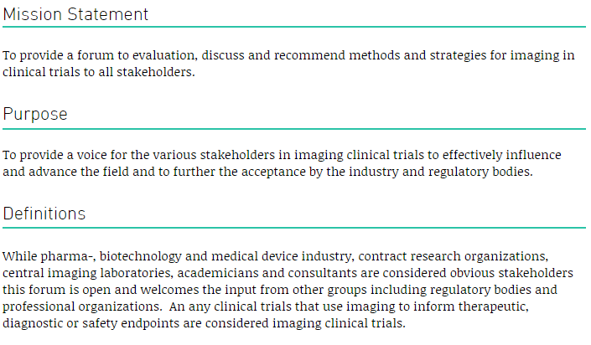
- Those on the phone accepted and welcomed the change. Annette Schmid to implement and highlight in the next mailings to the group.
- Next month’s topic: Greg Goldmacher will provide an update on immune related criteria for solid tumors

- Reminder to submit questions that would benefit from FDA feedback

